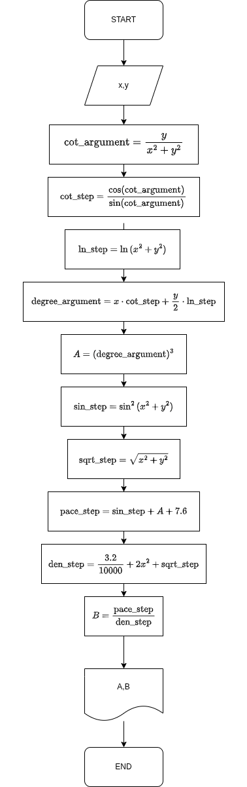
1-Jadval. 11-misol
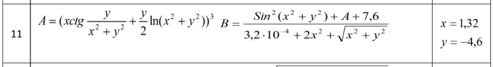

#include <iostream>
#include <cmath>
using namespace std;

int main() {
double x,y,A,B;
cout<<"x=";
cin>>x;
cout<<"y=";
cin>>y;

double cot_argument = y/(pow(x,2)+pow(y,2));
double cot_step = cos(cot_argument)/sin(cot_argument);
double ln_step = log(pow(x,2) + pow(y,2));
double degree_argument = x*cot_step + y/2*ln_step;
A = pow(degree_argument,3);

double sin_step = pow(sin(pow(x,2) + pow(y,2)),2);
double sqrt_step = sqrt(pow(x,2)+pow(y,2));
double pace_step = sin_step + A + 7.6;
double den_step = 3.2/10000 + 2*pow(x,2) + sqrt_step;
B = pace_step/den_step;

cout<<"A="<<A<<endl<<"B="<<B;
return 0;
}

Ibrohimov Abdulloh 313-25
Github

2-Jadval. 11-misol
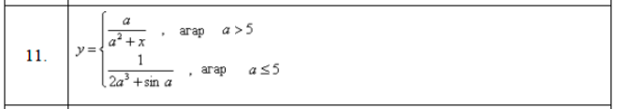
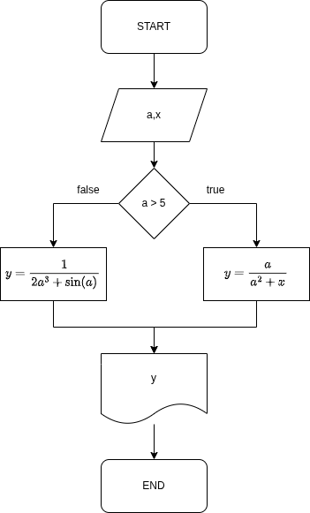
#include <iostream>
#include <cmath>
using namespace std;

int main() {
double a,y,x;
cout<<"a=";
cin>>a;
cout<<"x=";
cin>>x;
if(a > 5){
y = a/(pow(a,2)+x);
} else{
y = 1/(2*pow(a,3)+sin(a));
}

cout<<y;

return 0;
}

Github

Ibrohimov Abdulloh 313-25

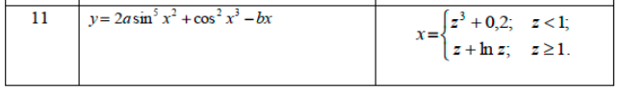
3-Jadval. 11-misol
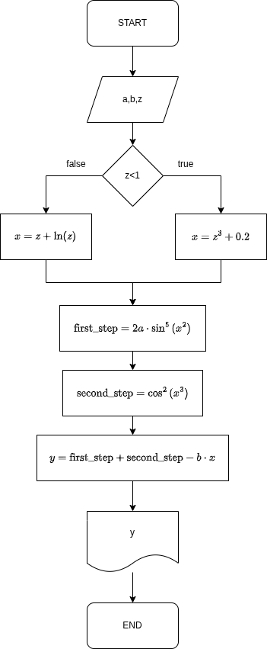
#include <iostream>
#include <cmath>
using namespace std;

int main() {
double a,b,y,x,z;
cout<<"a=";
cin>>a;
cout<<"b=";
cin>>b;
cout<<"z=";
cin>>z;

if(z<1){
x=pow(z,3)+0.2;
}else{
x=z+log(z);
}

double first_step=2*a*pow(sin(pow(x,2)),5);
double second_step=pow(cos(pow(x,3)),2);
y=first_step+second_step-b*x;

cout<<"y="<<y;
return 0;
}

Github

Ibrohimov Abdulloh 313-25

